**Data Security and Privacy in Big Data Analysis Using IBM Cloud Databases**

|  |  |
| --- | --- |
| **Date** | **26-10-2023** |
| **Team ID** | **4190** |
| **Project Name** | **Data Security and Privacy in Big Data Analysis Using IBM Cloud Databases** |

**Table of Contents**

|  |  |
| --- | --- |
| 1. | Introduction |
| 2. | Problem Statement |
| 3. | Advanced Analysis Techniques |
| 4.1 | Time Series Analysis |
| 4.2 | Holt-Winters Exponential Smoothing method. |
| 4.3 | Code for historical product demand analysis |
| 5. | Visualization of Analysis |
| 6. | Conclusion |

**1. Introduction**

In the era of data abundance, organizations are accumulating massive datasets across diverse domains, presenting both opportunities and challenges. IBM Cloud Databases offer a robust platform for Big Data analysis, promising the discovery of valuable insights and data-driven adventures. and this project aims to utilize innovative approaches to enhance prediction accuracy and reliability on data security and privacy in Big Data analysis.

**2. Problem Statement**

The project involves delving into big data analysis using IBM Cloud Databases. The primary objective of the project is to implement robust data security and privacy measures in the context of big data analysis using IBM Cloud datasets. This involves safeguarding sensitive information from potential threats, ensuring compliance with relevant regulations, and enabling secure and ethical use of data for analytics purposes. The project includes designing the analysis process, setting up IBM Cloud Databases, performing data analysis, and visualizing the results for business intelligence.

**3. Advanced Analysis Techniques:**

**Time Series Analysis with ARIMA or Exponential Smoothing:** Time series analysis is crucial for understanding and forecasting demand patterns over time. ARIMA (AutoRegressive Integrated Moving Average) and Exponential Smoothing models are widely used for this purpose.

**Machine Learning Regression Models:** Regression models, such as linear regression or advanced algorithms like XGBoost, can capture complex relationships between demand and various features like time, promotions, or external factors.

**Deep Learning with Recurrent Neural Networks (RNNs) or Long Short-Term Memory (LSTM) Networks**: Deep learning models, particularly RNNs and LSTMs, are effective for capturing sequential dependencies in time series data. They can learn patterns in demand with a focus on long-term dependencies.

**Customer Reviews and Sentiment Analysis:** Analyzing customer reviews and sentiments provides insights into how consumer perception impacts demand. Sentiment analysis, using natural language processing (NLP), helps understand the qualitative factors affecting product demand.

**Ensemble Models for Robust Predictions:** Combining the predictions of multiple models using ensemble techniques (e.g., stacking, blending) can enhance predictive accuracy. Ensemble models are particularly useful when different models capture different aspects of demand patterns.

These techniques, when applied judiciously, can provide a comprehensive understanding of historical product demand, enabling more accurate forecasting and better-informed decision-making. Keep in mind that the choice of technique depends on the characteristics of your dataset and the specific goals of your analysis.

**4.1 Time Series Analysis:**

The journey begins with rigorous data preprocessing to address missing values, outliers, and enhance data quality. Exploratory Data Analysis (EDA) reveals temporal patterns, seasonality, and trends. Depending on the nature of the data, temporal aggregation is applied to achieve the desired granularity. A judicious choice of time series models, ranging from ARIMA to advanced models like Prophet, is made to accurately forecast demand. Model validation is conducted through robust evaluation metrics on training and testing datasets.

Harmonizing advanced time series analysis with stringent data security and privacy measures is imperative for extracting meaningful insights from historical product demand data on IBM Cloud. This integrated approach safeguards sensitive information, fosters compliance, and enhances the ethicality of data analysis practices.

**4.2 Holt-Winters Exponential Smoothing method:**

In Historical product demand analysis, the Holt-Winters Exponential Smoothing method offers a robust approach for time series forecasting. This delves into the application of this technique while prioritizing data security and privacy within the realm of big data analysis using IBM Cloud datasets.

**Holt-Winters Exponential Smoothing:** Holt-Winters is a time series forecasting method that captures trends, seasonality, and level components. It provides a powerful tool for predicting future values based on historical data patterns.

**Data Security and Privacy Measures:**

**Encryption Protocols:** Implement end-to-end encryption protocols for data in transit and at rest within the IBM Cloud, safeguarding historical demand data against unauthorized access.

**Access Controls and RBAC**: Enforce strict access controls and Role-Based Access Control (RBAC) mechanisms, ensuring that only authorized personnel have access to the historical demand dataset.

**Anonymization Techniques:** Apply anonymization techniques to shield personally identifiable information (PII) in the historical demand dataset, aligning with data privacy regulations and safeguarding customer identities.

**Secure Data Transmission:** Utilize secure data transmission protocols, such as HTTPS, to protect historical demand data during transit between cloud components and external entities.

**Implementation Steps for Holt-Winters Exponential Smoothing:**

**Data Preprocessing:** Conduct thorough data preprocessing, handling missing values and outliers, and ensuring the quality of the historical demand dataset.

**Exploratory Data Analysis (EDA):** Perform EDA to gain insights into temporal patterns, seasonality, and trends within the historical demand data.

**Temporal Aggregation:** Choose an appropriate temporal aggregation level based on the nature of the data, aligning with the desired analysis granularity (e.g., daily, weekly, monthly).

**Model Selection and Validation:** Select the Holt-Winters Exponential Smoothing model, considering the seasonality and trend components. Validate the model's performance using training and testing datasets.

**Secure Deployment on IBM Cloud:**

**Fortified Cloud Environment:** Configure a secure cloud environment on IBM Cloud with robust firewalls, continuous monitoring, and auditing capabilities to detect and respond to security incidents.

**Tokenization for Sensitive Data:** Employ tokenization methods for preserving the utility of sensitive data elements while maintaining their confidentiality.

**Monitoring and Ethical Considerations:**

**Real-time Monitoring:** Implement real-time monitoring mechanisms to promptly identify anomalies during the time series analysis, enhancing security incident response.

**Ethical Communication:** Transparently communicate with stakeholders about the purpose, methodology, and ethical considerations of time series analysis, fostering trust and compliance.

The application of Holt-Winters Exponential Smoothing in historical product demand analysis on IBM Cloud is a powerful technique when coupled with stringent data security and privacy measures. This integrated approach ensures the extraction of meaningful insights while respecting privacy regulations and maintaining the confidentiality of sensitive information.

**4.3 Code for Historical Product Demand Analysis:**

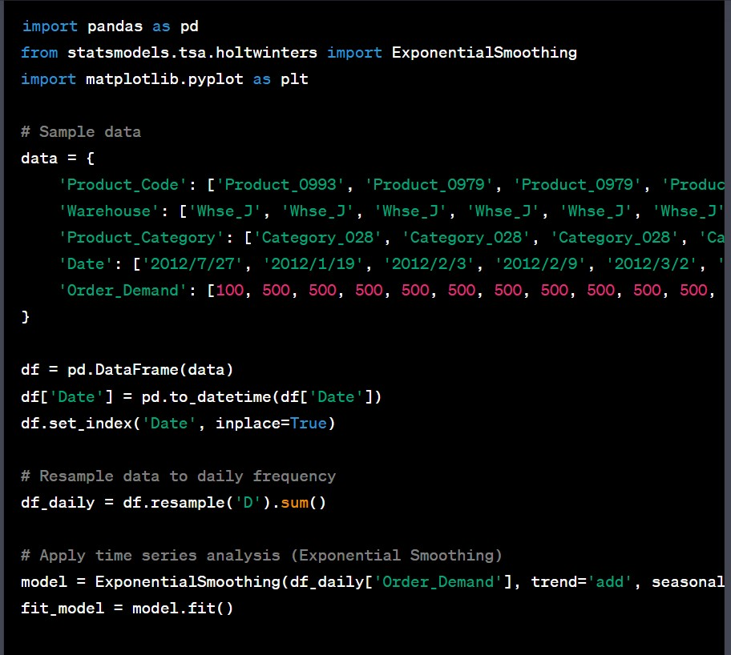

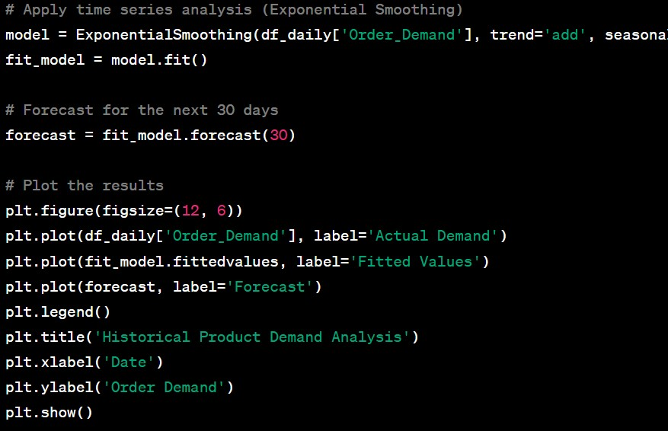

To perform historical product demand analysis using Python, Time series analysis can be utilized. This python program uses the pandas library for data manipulation and the statsmodels library for time series analysis.

**5. Visualization of Analysis:**

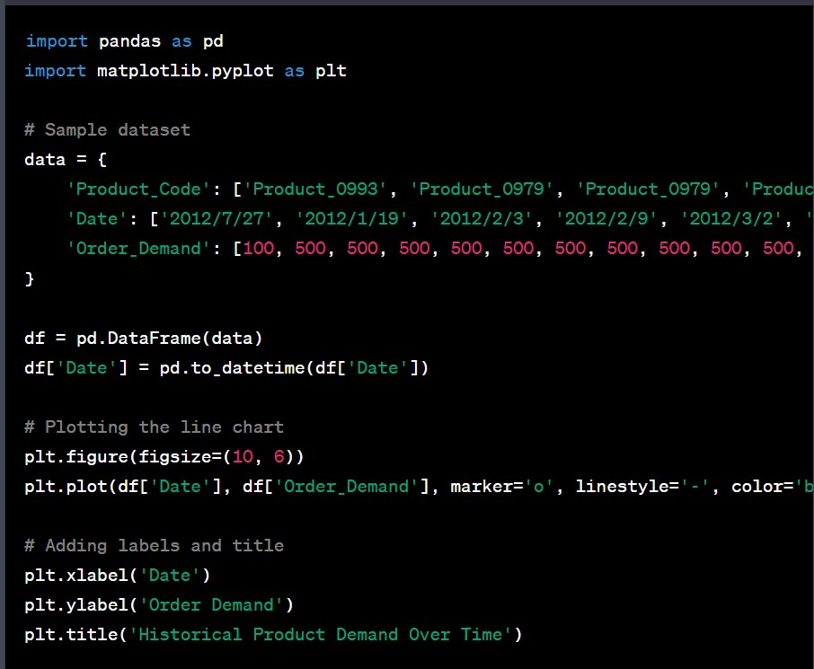

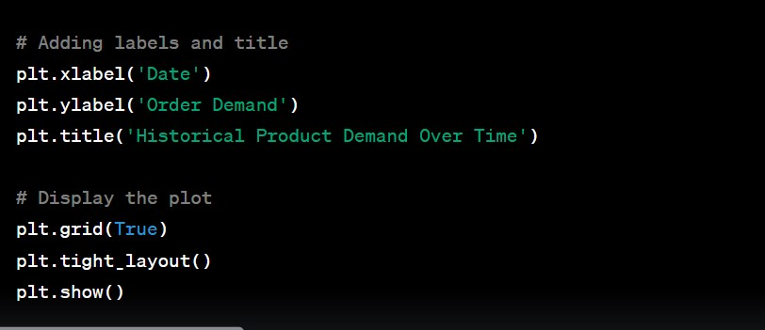

**Visualization of python using Matplotlib:**

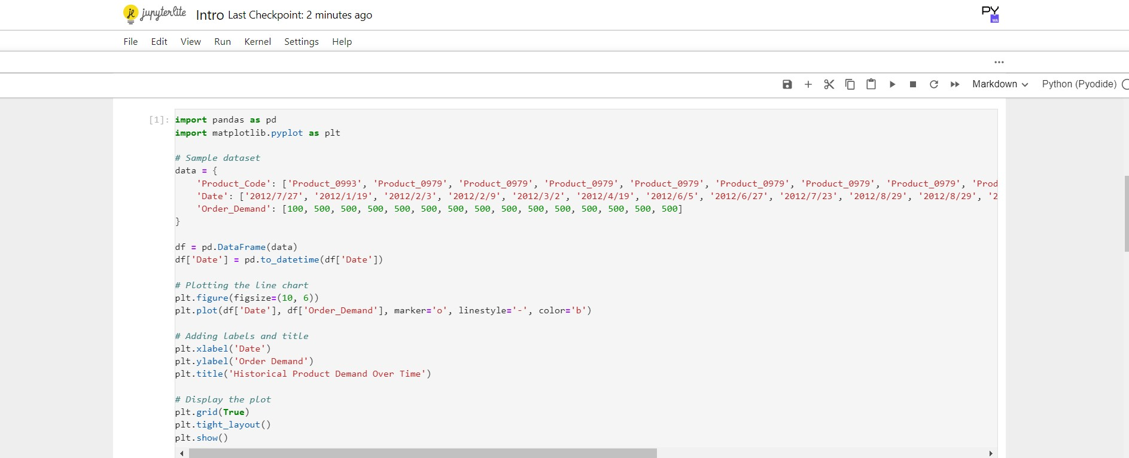

**Visualizing the Selected Dataset:** 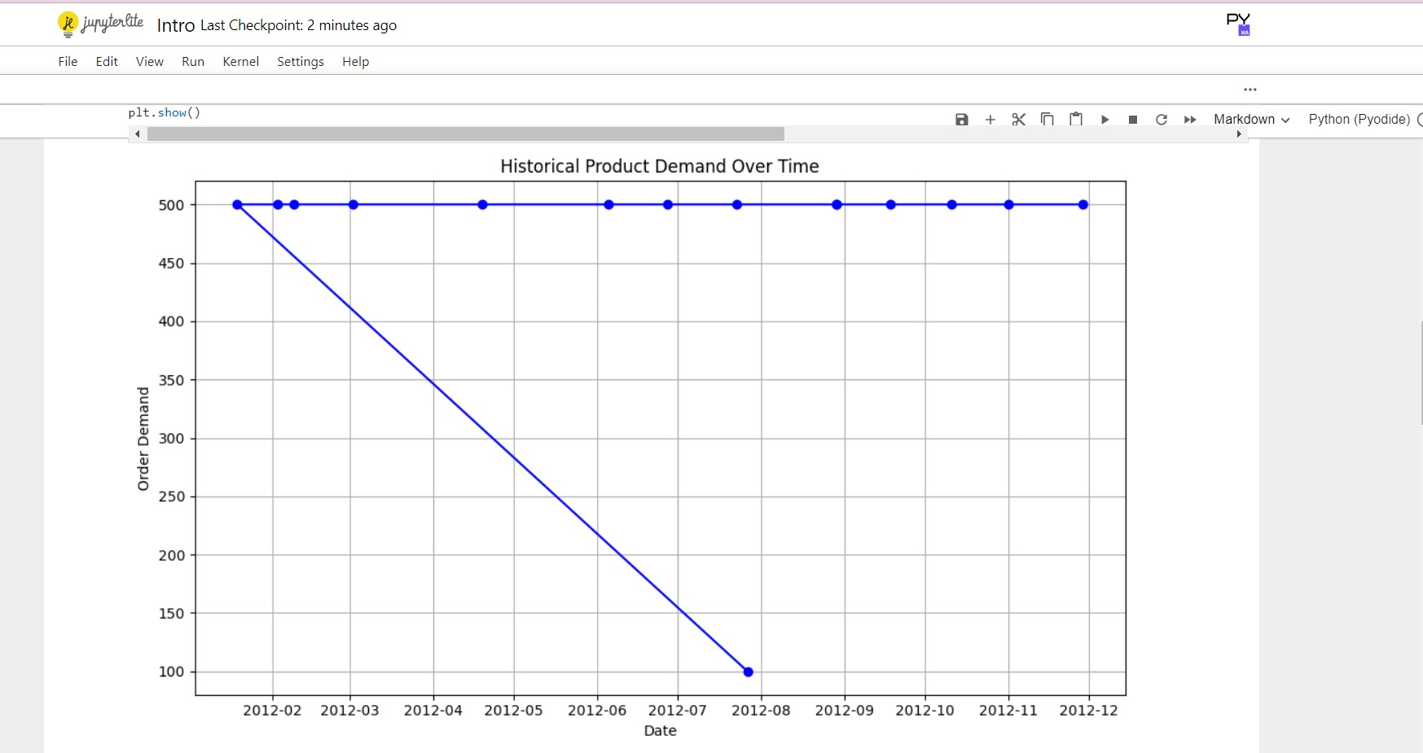

**6.Conclusion:**

The synergy between advanced analytics and data security is not merely a technical requirement but a commitment to ethical and responsible data handling. The journey from data exploration to secure time series analysis underscores the importance of harmonizing technological prowess with ethical considerations in the evolving landscape of big data analysis.